
MORNING STAR SCHOOL
ACADEMIC SESSION 2024-25
SUMMER HOLIDAY HOMEWORK
Class-IX
GENERAL INSTRUCTIONS
⭐The assignment should be done as per the instructions given.
⭐It should be neatly labelled with your name, class and section mentioned clearly.
⭐The last date of submission of holiday assignment is 5thJuly 2024.
⭐Students are requested to do a lot of reading of books related to their stream & newspapers.
⭐ Prepare yourself for the Periodic Test-I which is going to be held in the month of July.
Holiday homework is intended to make students independent and enhance their skills and capabilities. Holiday homework helps to keep students on track and keep their brains ticking.

Subject:-ENGLISH
- Revise all the topics covered up to now .
- Spend quality time with your parents and write a diary entry of your experience. You can capture the moment and share in the diary.
- Write a letter to the Chairman, Water Authority, in up to 120-150 words, on the problems related to scarcity of water. Also suggest a few effective remedies.

Subject:-HINDI
1.नीचे लिखे विषयों पर नारे लिखिए। (चित्र सहित)
1. हिंदी दिवस
2. योग का महत्व
3.कोरोना
4.स्वच्छता
2.संधि की परिभाषा व प्रकारों का सचित्र वर्णन कीजिए
3.तुलसीदास या कवीरदास का जीवन परिचय व रचनाओं का सचित्र वर्णन कीजिए
(किसी एक विषय पर परियोजना कार्य करना है।)
Subject:-MATHEMATICS
- If x + y = 12 and xy = 32, Find the value of x² + y².
- If 3x + 2y = 12 and xy = 6, find the value of 9x² + 4y².
- Write the following cubes in the expanded form:
  - (3a + 4b)³
  - (5p – 3q)³
- If x+ 2y =2 & xy=1 then find the value of X²+4y²
- Using suitable identity evaluate (12)³ + (-7)³+ (-5)³ .
- If a + b + c = 15 and a² + b² + c² = 83, find the value of a³ + b³ + c³ – 3abc.

- Factorize:
  - 6ab – b² + 12ac – 2bc
  - 9(2a – b)² – 4(2a – b) – 13
- If x³ + ax² – bx + 10 is divisible by x² – 3x + 2, find the values of a and b.
- Using factor theorem, factorize each of the following polynomials:
  - X³ – 6x² + 3x + 10
  - 2y³ – 5y² – 19y + 42
- Which one is not a polynomial
    - 4x² + 2x – 1
(b) x³ – 1
(c) Y⁻² + 5y + 1
- The number of zeros of x² + 4x + 2
    - 1
    - 2
(c) 3
(d) None of these
- The value of k, if (x – 1) is a factor of 4x³ + 3x² – 4x + k, is
    - 1
    - 2
(c) -3
(d) 3
Subject:-SCIENCE
☆ PHYSICS
1. A physical quantity which has both magnitude and direction is called
(a) scalar quantity (b) vector quantity (c) neither (a) nor (b) (d) either (a) or (b)
2. The rate of change the velocity per second is known as.
(a) acceleration (b) speed (c) distance (d) time
3. SI unit of velocity and speed both is
(a) meter (b) meter/second (c) second (d) All of these
4. Which of the following is a scalar quantity?
(a) Velocity (b) acceleration (c) displacement (d) distance
5. Which of the following is not a vector quantity?
(a) speed (b) acceleration (c) velocity (d) displacement
6.Distance and displacement are two quantities that seem to mean the same but are different with different meanings and definitions. Distance is the measure of “how much distance an object has covered during its motion” while displacement refers to the measure of “How far is the object actually from initial place?” Using this data answer following questions.
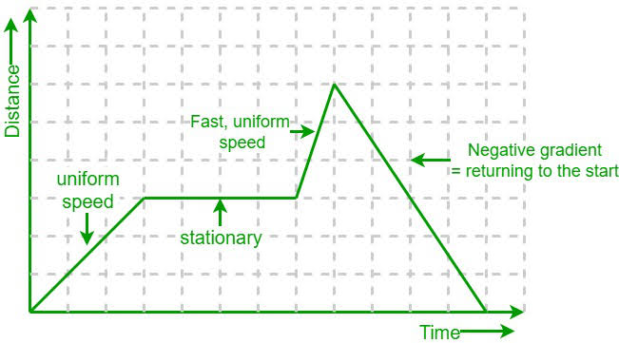

(i) Which of the following relation is always true when object moves in straight line?
(a) Distance is always equal to displacement.
(b) Distance is always greater than or equal to displacement.
(c) Distance is always lesser than or equal to displacement
(d) None of the above.
(ii) Kapil travels 20 km to North but then come back to South for 40 km to pick up a friend. What is kapil’s total distance?
(a) 60km (b) 80km (c) 20km (d) none of the above

7.Study the speed time graph of a body given here and answer the following questions

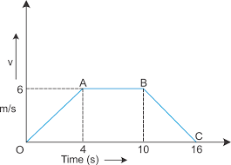
(i) What type of motion is represented by OA.
(ii) What type of motion is represented by AB.
(iii) What type of motion is represented by BC.
8. Define the following term with block diagram.
(i) Distance (ii) Displacement (iii) Uniform motion (iv) Non uniform motion
9. Draw distance time graph for an insect moving steadily on ground.
10. How velocity is different from speed?
11.Draw the following
(i) Distance-time graphs for uniform and non uniform motion.
(ii) Velocity -time graph for uniform velocity.
12. Draw distance time graph on the basis of given table.
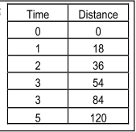
- Describe the following graph with example
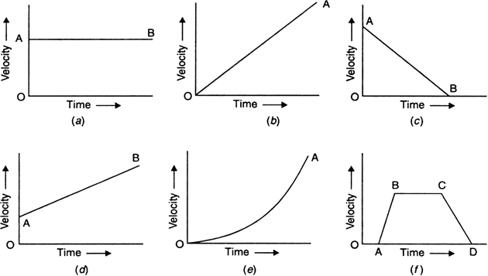

☆

BIOLOGY
Writing :
- Complete the notes of chapter 1 Cell The fundamental unit of life
- Complete the NCERT question and answer in fair notebook.
- Complete the given worksheet :
  - Write the difference between plant cell and animal cell
  - Write the difference between prokaryotic and eukaryotic cell.

III. Write the similarities and differences between mitochondria and
plastids.
IV. What are lysosomes? Why lysosomes are called suicidal bags?
V. How does an amoeba obtain their food?
VI. Draw the diagram of plant cell and animal cell.
Learning:
- Important terms, very short question answer, short question answer, long answer of chapter cell.
Practice:
Do practice of diagrams given in the chapter.
Chemistry
1) NCERT solutions chapter no 1
2) project based on chapter 1
Subject:-SOCIAL STUDIES
📌The Following Assignment Has to be Done in the Notebooks:
1. What was Jacobin club?
2. Name any 3 non farm activities that were performed by people in Palampur.
3. Why does India use a standard meridian? What is the standard meridian for India?
4. Elaborate the French society structure in the 18th century.
5. Why is the northern plain the most populated and island moderately populated?
6. Write Rise Fall of Napoleon Bonaparte make a album of Napoleon?
7. What is the latitudinal and longitudinal extent of India?
8. How did the businessmen pursue their work in Palampur?
9. Write the Merits and Demerits of Democracy.
10. What are the modern tools and techniques used by the farmers now a days make a list of it and write about formal and non formal source of credit?
11. Make a manuscript: Take a broad leaf. Put it under a heavy book for ten days. On the leaf write the Preamble of the Indian Constitution?
12. Make a political map of India and locate all the States and Union Territories:
13. On physical map of India locate all physical features.
Subject:- COMPUTER
- Complete your work of chapter-1 (Question Answers) in computer notebook
- Write notes on following topic:- (ASSIGNMENT FILE )
- Emerging Technology
- Importance of Computer in Education.
- Computer Programming

- Discuss the role of computer in our life. (ASSIGNMENT FILE )

*ACTIVITY RECOMMENDED DURING VACATION*
- Meditate and do simple yoga exercises .
- Water plants and feed the birds.
- Join your grandparents and parents for their morning walk.
- Help your mother in the kitchen .
- Don’t watch too much of television .
- keep your environment in surrounding clean .
- Plant trees and conserve your natural resources.
- Build and improve your vocabulary through crosswords, jumble words etc.
- Solve riddles and puzzles.
- Read story books and visit places.
- Improve your reading and writing skills by reading and writing.
Note:
- Summer breaks are from 5th May to 23 June 2024. The school will
reopens on 24th June 2024

Have a great
Summer Vacation

